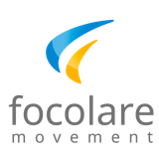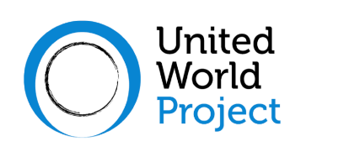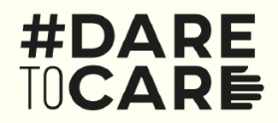

**Accessible Environment**

**Inclusive Society**

[*www.aeis.cloud*](https://www.aeis.cloud/)

*Four webinars to reflect on the culture of accessibility, to share experiences on how to build a world without any architectural, technological, cultural, or social barriers that may exclude many people from fully participating in society*.

**New perspectives from experiencing limits** *(Saturday September 11, 2021)*

**Accessibility and built environment** *(Saturday October 9, 2021)*

**Accessibility to information and communication** *(Saturday Nov 13, 2021)*

**Accessibility and inclusion** *(Saturday December 11, 2021)*

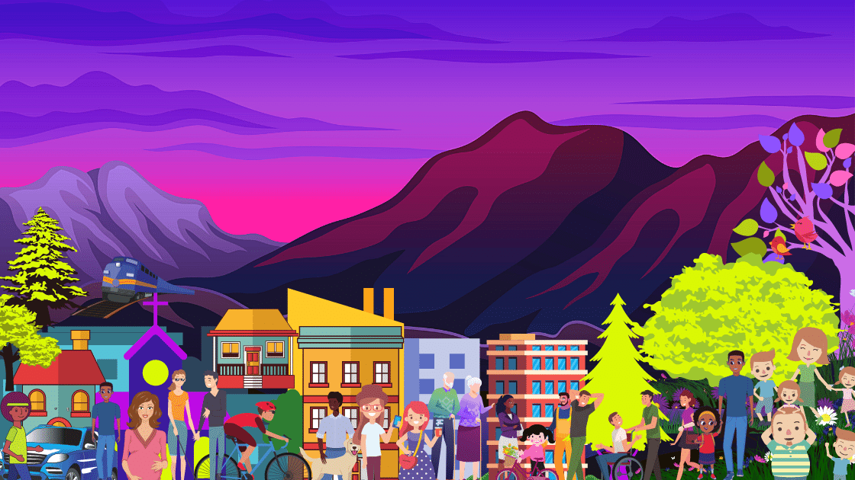

**h. 2 pm (Italian time)**

|  |  |
| --- | --- |
| Logo of Zoom, to indicate that the webinars will be held online through Zoom | Logo of YouTube, to indicate that the  webinars can be watched on YouTube live streaming |

*Instructions for participating though Zoom or watching the YouTube streaming:*

*See the project web site a few days before each Webinar*