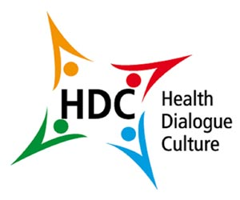
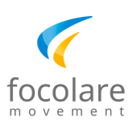
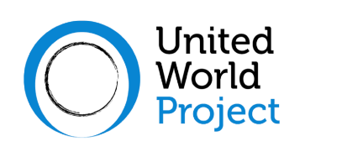
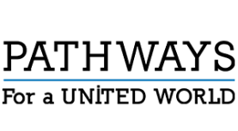

Accessible Environment
Inclusive Society
Accessibility
and built environment

Second webinar, to reflect on the culture of accessibility, to share experiences on how to build a world without any architectural, technological, cultural, or social barriers that may exclude many people from fully participating in society.

www.aeis.cloud
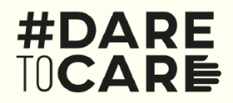
Saturday October 9, 2021
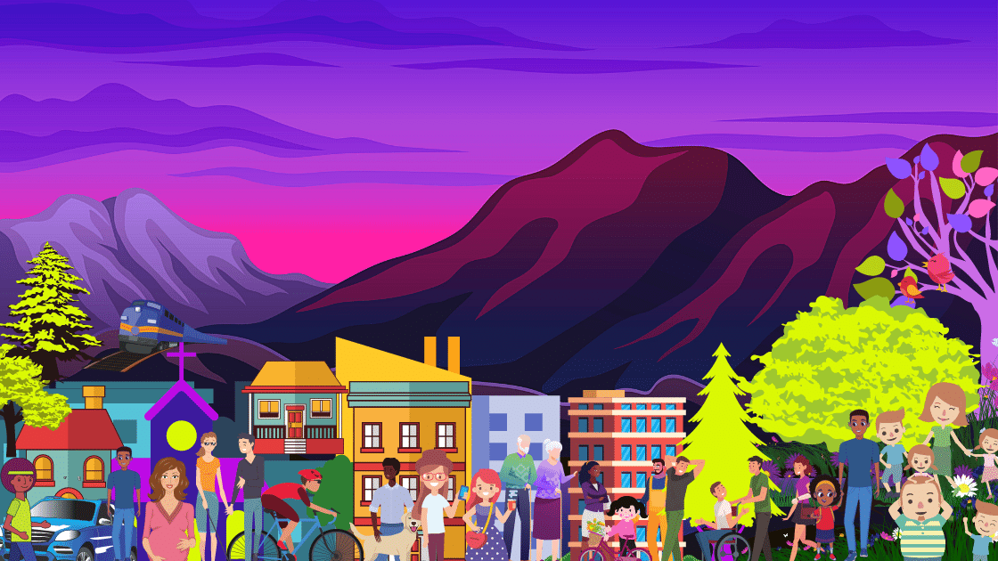
2 pm (Rome time - UTC 16)
For instructions on how to participate through Zoom or watch streaming on YouTube
see the project website www.aeis.cloud

